**Linux Fundamental Assignment 1**

Setting up Static IP on CentOS Server

Command: vi /etc/sysconfig/network-scripts/ifcfg-enp0s3

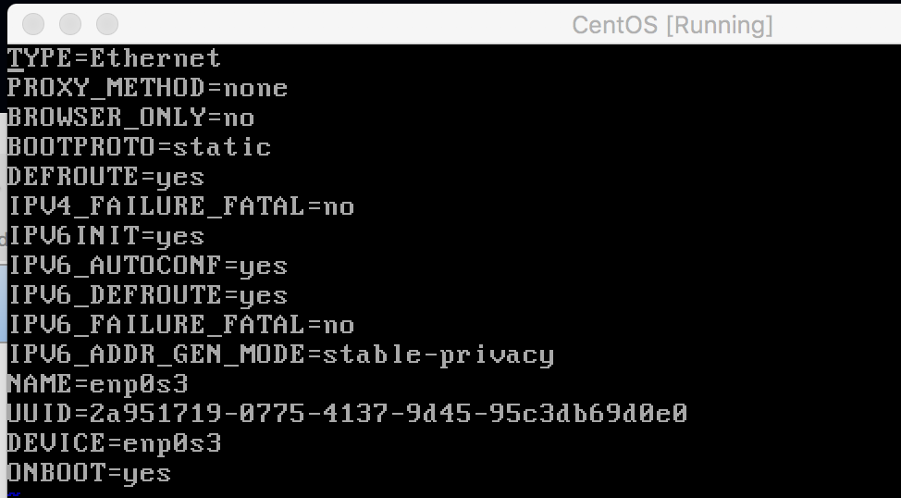Change BOOTPROTO=static

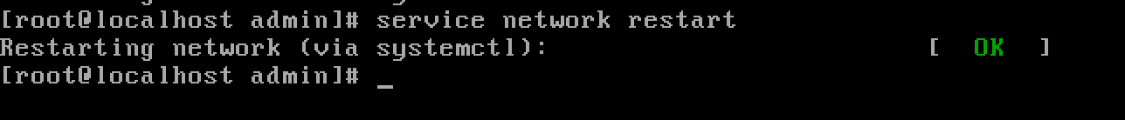Restart the service to commit the changes